# Job Aid: Accessing the Legacy HuB with Tyson Credentials

The legacy Hillshire HuB is moving to the Source. In order to access the HuB through the Source, you will need to take the following steps. You will need your Tyson email address and password in order to log on to the HuB through the Source.

## Prepare Internet Explorer by Clearing Cookies

*Only complete these steps after the HuB has been fully migrated to The Source. You will need to clear your cookies on any legacy Hillshire computer or mobile device.*

1. Click the Internet Explorer icon on the taskbar to open Internet Explorer.
2. Click the **Tools** button( Tools button ), point to **Safety**, and then click **Delete browsing history…**  
   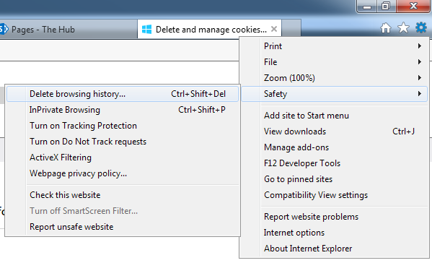
3. A **Delete Browsing History** window will be displayed.
4. Uncheck **Preserve Favorites website data**.
5. Check the **Cookies and website data** check box.
6. Click **Delete**.

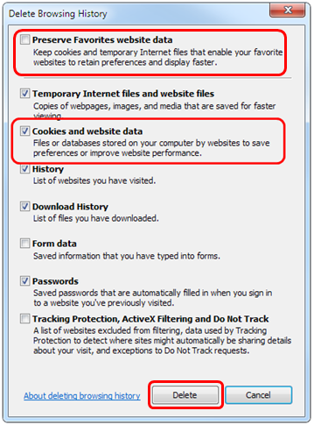

6

5

4

1. Your Internet Explorer cookies have been cleared.

## Accessing the HuB from The Source

1. Access the Source: <http://source.tyson.com>
2. Click on the HuB banner at the bottom of the page.



Or access it via the URL: https://tysononline.sharepoint.com/sites/HuB

1. Login using your Tyson email address.
   1. If presented with options, choose “Use another account”. Do **NOT** choose your Hillshire Brands user account.

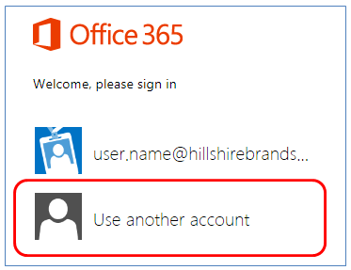

*NOTE: If the above screen is not presented to you, go to step 3b.*

* 1. Enter your Tyson Email address and Select .
     1. Click the button.

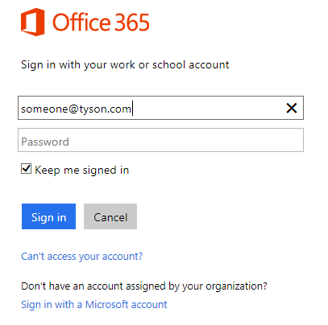

1. A pop-up **Windows Security** window will be displayed
2. Enter your Tyson email address or domain login.
   1. Enter your Tyson **email address** and domain password.

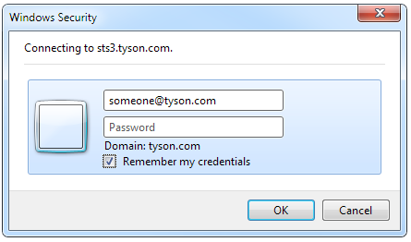

* 1. If your email address is **NOT** recognized, use your **domain login** instead. Your domain login should be input in the format: **TYSONET\USERNAME.**
     1. Note that your Tyson username will be different than the legacy Hillshire format of first.last

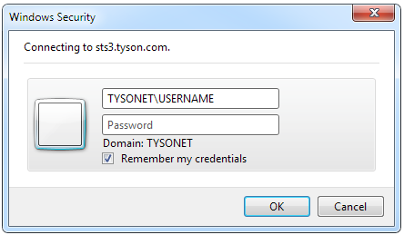

1. Select “**[x] Remember my credentials”.**
2. Press the **OK** button.
3. You are not logged into the HuB on Tyson Online.

## Troubleshooting

Your Tyson email and password were sent to you on April 13 in an email from [ISSecurityAdmin@tyson.com](mailto:ISSecurityAdmin@tyson.com). If you do not know your username or password or are unable to find the email, please contact the **Tyson Help Desk** at **1-800-866-4357.** They will be able toprovide your Tyson username and provide you with steps to reset your password.

ISSUE 1

I get a “That didn’t work” message that states “External sharing is disabled for [**https://tysononline.sharepoint.com/**](https://tysononline.sharepoint.com/).”

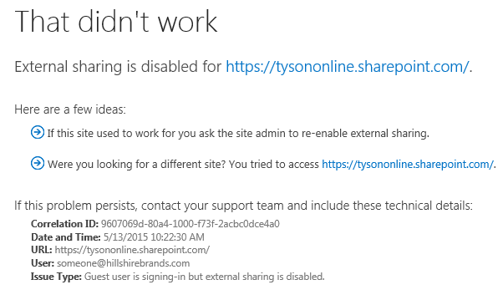

SOLUTION: You are still logged into your Hillshire account. Clear your cookies or log off of the HuB using the steps provided in this job aid.

The URL address is also incorrect. The correct URL is: https://tysononline.sharepoint.com/sites/hub